Team PCODERS

Q1 : Burglar alarm :

<https://www.multisim.com/content/KdT69etxt7z7ycLsFbPozY/q1/open/>

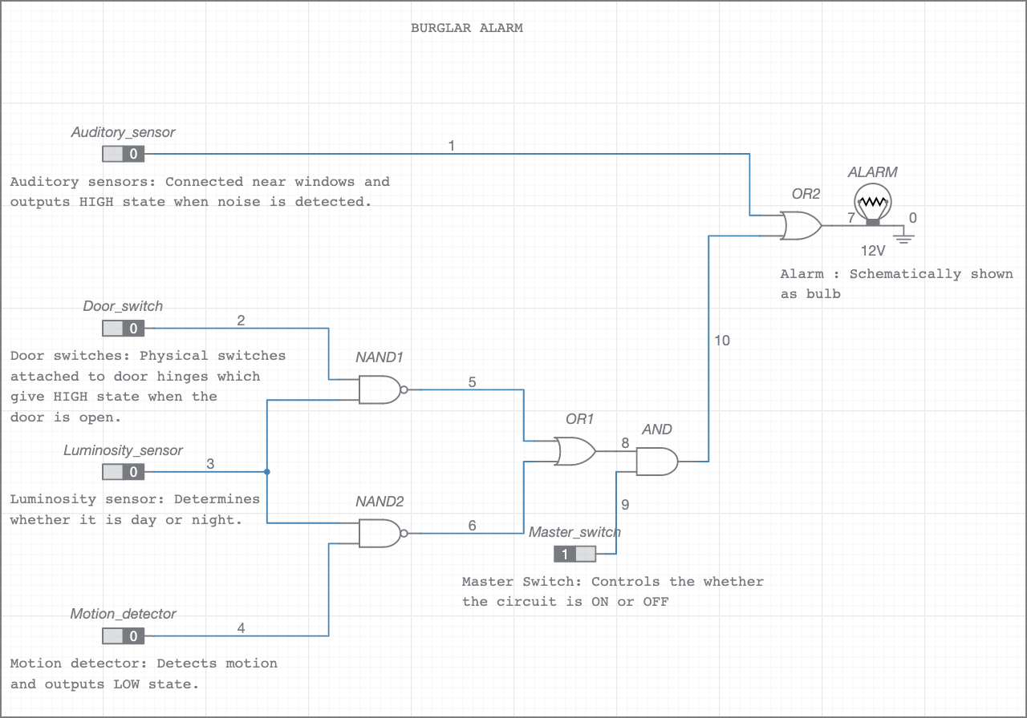

Q2-a : Prime number detector : <https://www.multisim.com/content/Dq7xTzYWwbDWPXRXf9fqoA/q2-a/open/>

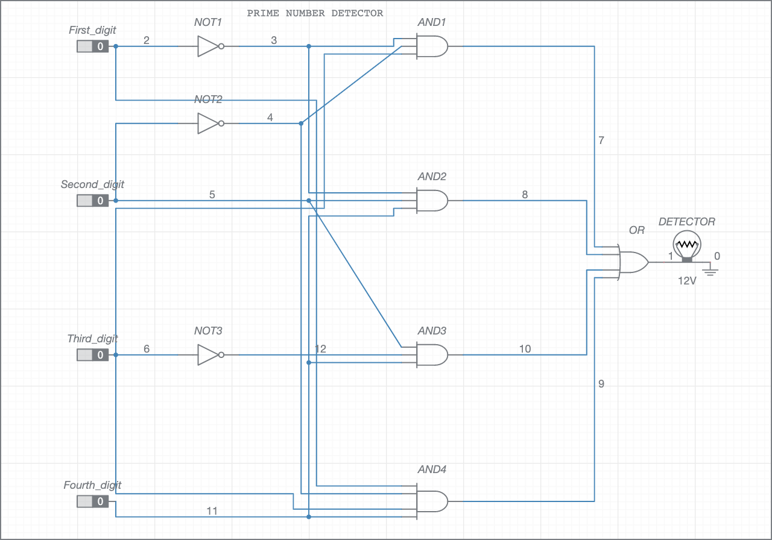

Q2-b : Fibonacci number detector :

<https://www.multisim.com/content/MDyAEznyrhV4ce9TdxomZP/q2-b/open/>

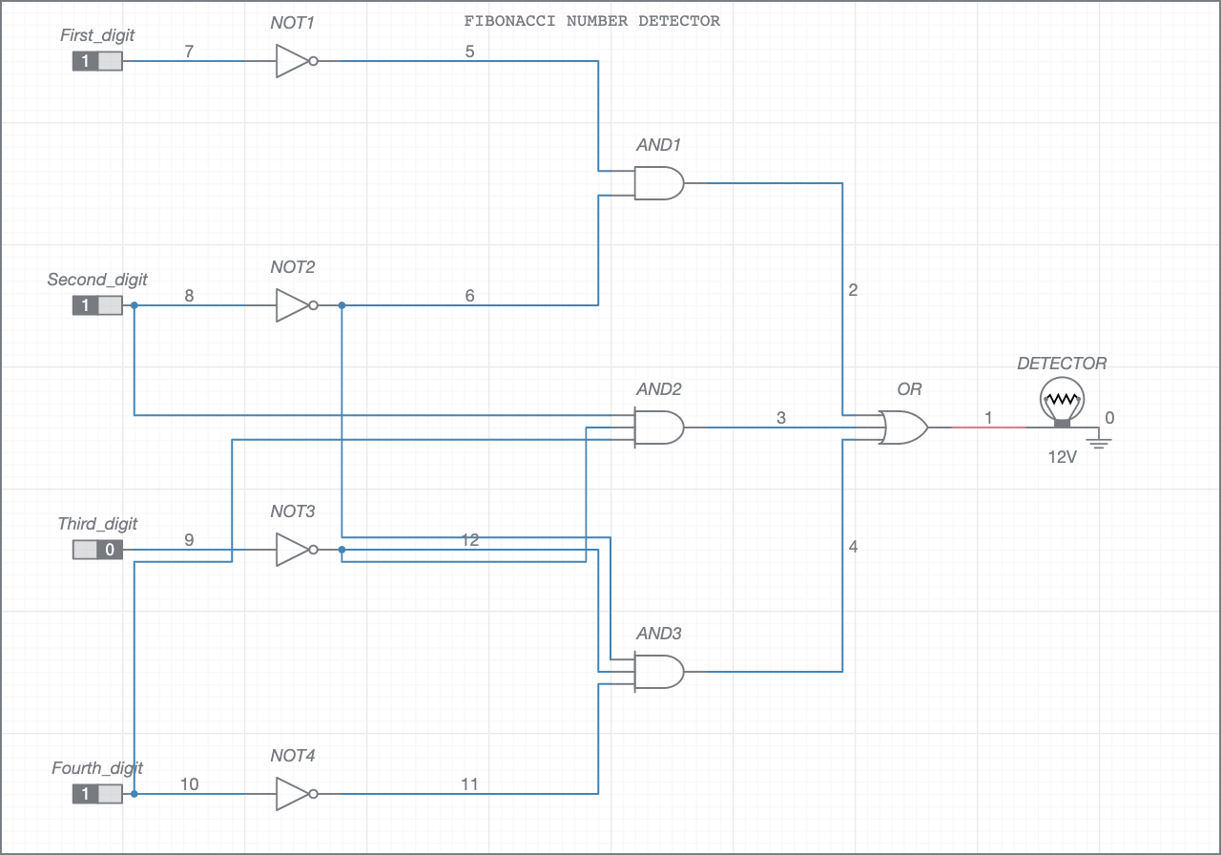

Q2-c : Tribonacci number detector :

<https://www.multisim.com/content/95EEvgHC9ohLLpkhieAKs2/q2-c/open/>

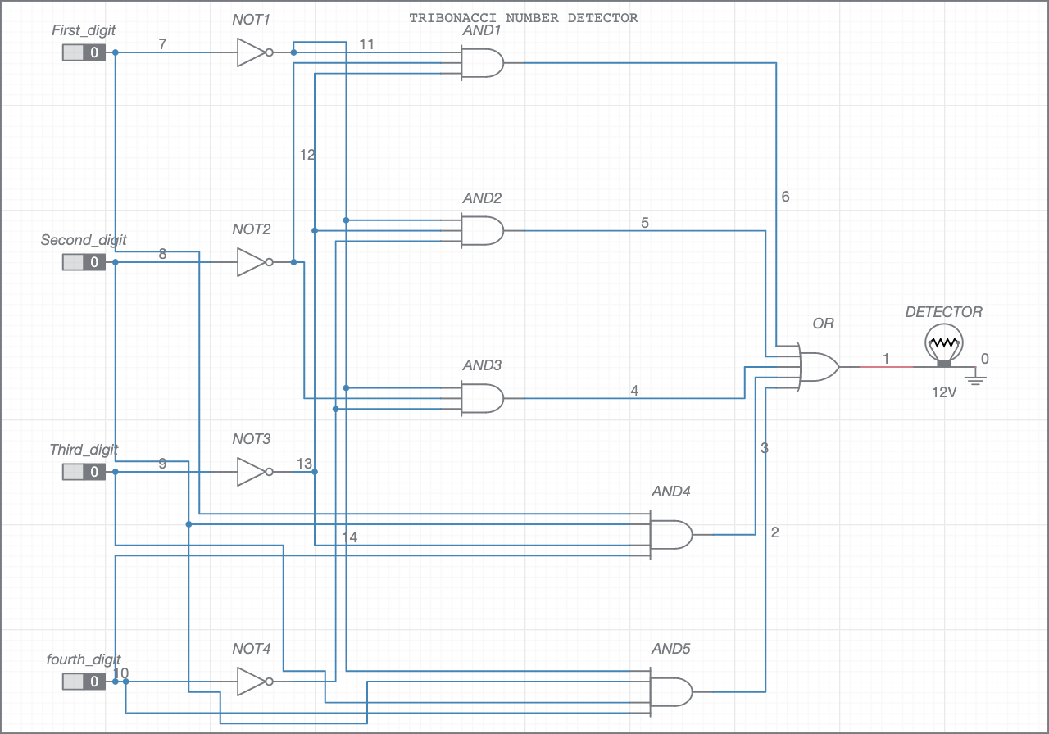

Q2-d : Catalan number detector :

<https://www.multisim.com/content/EQbj6tA7ARFQhghRbbDk3Y/q2-d/open/>

